Margaret Roach, former garden editor of Martha Stewart Living [Gardens in Copake, NY, blogs at A WAY TO GARDEN (http://awaytogarden.com/)]
THE SEED SERIES TOPICS: http://awaytogarden.com/tag/seed-series/

- Lessons from Thomas Jefferson’s vegetable garden  - Shopping the seed catalogs  - Oddball edibles: unusual vegetables to grow  - Best tomatoes: heirloom picks, plus the dwarf tomato project  - How to grow spinach (w. Tom Stearns of High Mowing)  - Crazy cucurbits  - Grow onions from seed  - A new ‘brand’ of seed in town: OSSI (open source seed initiative) | 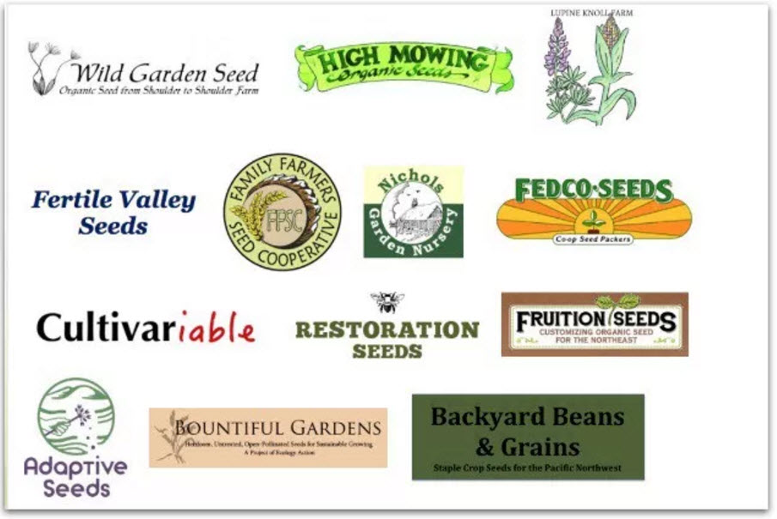
FABULOUS FAQ TOPICS: http://awaytogarden.com/garden-faq/

12 Top Composting FAQs: What to put in the heap (and not); what to enclose it all in (or do you even need a bin at all?); how to speed things up, when (and whether) to turn, and all the other key how-to’s of making black gold.
Flower-Bulb FAQs: Why didn’t your daffodils bloom? How to grow dahlias? What bulbs will naturalize (and not); which ones are animal-proof? All this and more.
Pruning FAQs: When to prune what, and how to make the basic cuts. Lilacs, fruit trees, hydrangeas and more.
Mulch FAQs: What makes good mulch (and doesn’t)? When and how much to apply? Do you mulch pots, too? And more.
Tomato-Growing FAQs: Heirlooms or hybrids? How deep and when to plant? From seed, step-by-step; staked vs. caged. And more.
Tomato-Troubles FAQs: Worried about late blight? Have hornworms, or spots on leaves, no fruit set or fruit that’s disfigured? The lowdown.
20 Top Seed and Seed-Starting FAQs: From tips and techniques to the ethics or organics and GMOs, the top answers about growing from seed.
Cucumber-Growing FAQs: Flowers but no cucumbers? Misshapen or bitter cukes? Wilting vines? And what in the world is a gherkin, really?
AWAY TO GARDEN TURNS 9 IN MARCH 2017, plenty old enough to have a “greatest hits” list. Here are the reader favorites. Enjoy!

- the tricky matter of when to harvest garlic
- what to plant now for a fall vegetable garden
- how to freeze parsley, chives and other herbs
- when to start seed
- tips for growing better tomatoes from seed
- farm-fresh peaches, frozen to perfection
- growing potatoes organically: when and how to plant, hill and harvest
- growing and storing a year of parsley
- Dan Koshansky’s refrigerator dill pickles
- 10 thoughts on successful underplanting
- what’s in pickling spice? some recipes
- why vegetable seedlings stretch and get spindly
- 6 lessons about hosta, with Tony Avent
- hot plant: Stewartia, an ideal small tree
- when to start what: vegetable-seed calculators
- there’s more than one way to ripen a tomato
- the toughest groundcovers I rely on
- slideshow of my 54 top shade plants
- what weed is it? putting names to pesky plants
- grow healthy tomatoes: staking and pruning
- garden prep: how to make a bed, with cardboard
- just saying no to deer, with fencing
- how to grow carrots, with dr. john navazio
- estimating viability: how long do seeds last?
- growing and storing a year of garlic
- beloved conifers: weeping alaska cedar
- from the forums: pruning viburnums
- skins-on easy tomato sauce to freeze
- when inner conifer needles turn yellow or brown
- soil-saving tricks for planting big pots
- clafoutis batter, universal solvent of fruit dessert
- 10 tips for growing blueberries in the backyard
- how to grow garlic, a q&a with Filaree Farm
- slideshow: 10 great groundcovers to rely upon
- beloved conifer: Japanese umbrella pine
- cucumber-growing q&a, and the best pickles ever
- mulch faq’s
- how trash helps me save on potting soil
- overwintering rosemary, indoors and out
- my top conifers for year-round garden beauty
- garlic harvest and curing: i did something right
- fear not! how to prune clematis
- tomato-growing faq’s
- when the normally tough peony fails to bloom
- the oddball houseplant Bowiea volubilis
- hugelkultur, nature’s raised garden beds
- growing a better tomato, seed to harvest
- caterpillar alert: who’s eating my cabbage and broccoli?
- an easy annual poppy, Papaver somniferum
- growing fancy-leaf begonias, indoors and out
- brrrr! overwintering tips for tender plants
- great shrub: bottlebrush buckeye
- pruning faq’s
- great shrub: Fothergilla, a multi-season star
- how to grow the best-tasting tomato
- how to store garden vegetables for winter
- in season: easy asparagus-parmesan bake
- fall planting: 21 powerhouse perennials I’d order
- let there be sweet potatoes: how to plant them
- here (finally!) come the hellebores
- 12 trees and shrubs for great fall foliage color
- voila! my first orchid reblooms
- Lee Reich’s blueberry-growing how-to
- organic lawn care with Paul Tukey: crabgrass control, reducing compaction
- growing (or just eating!) heirloom dry beans
- pruning lilacs
- baked pears for breakfast, or maybe dessert
- everything old is new: ‘green’ posters from the WPA
- great shrubs: a roundup of some favorites
- copper or purple beech, a tree worth waiting for
- radio podcasts: itunes, stitcher, stream, live
- a plant I’d order: Hakonechloa ‘All Gold’
- 12 top composting faq’s
- tomato-troubles faq’s
- battling mice and voles (but never with mothballs)
Plus mulch, mulch more… LEARN ALL YOU CAN!

