“FIGURING IT OUT” IN CONCORD’S NEW CLIMATE

Ben Elliott, owner of Salt Box Farm & chef of Salt Box Kitchen in Concord, and Mark Congdon, Salt Box Farm Manager, gave a talk at the Fowler Library in Concord on March 11, 2017. Here are some website links and book titles from the slideshow and talk that would be helpful for beginner or journeyman gardeners who want to take it to the next level.

I. Soil Health and Fertility
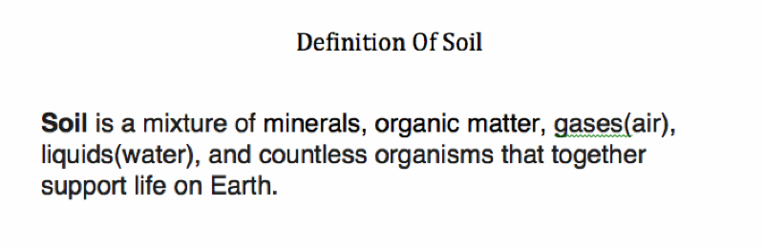

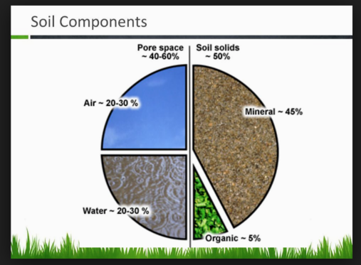

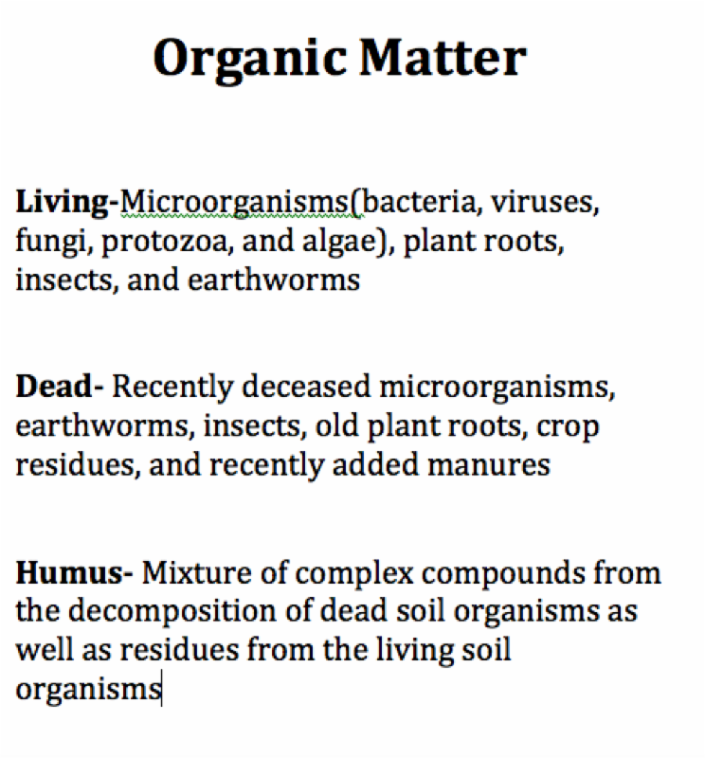

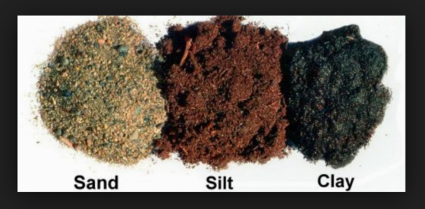
Triangle Soil Texture Test

Understanding Soil

Soil Testing

Building Healthy Soil

Cover Crops

Web Soil Survey by the USDA

Compost

II. Water

Drip Works Irrigation Systems

Watering Tips

Gardening Techniques For Dry Weather

US Drought Monitor Maps

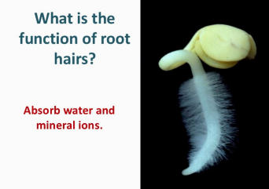

III. Crop Diversity & Rotation

Crop Diversity

Crop Rotations

Johnny's Selected Seeds (Where we get most of our seeds; you can search for heat-tolerant and disease-resistant varieties in their search bar)

A Few Book Titles

-Omnivore's Dilemma by Michael Pollan
-The New Organic Grower by Eliot Coleman
-Growing Great Garlic by Ron Engeland
-Second Nature by Michael Pollan

