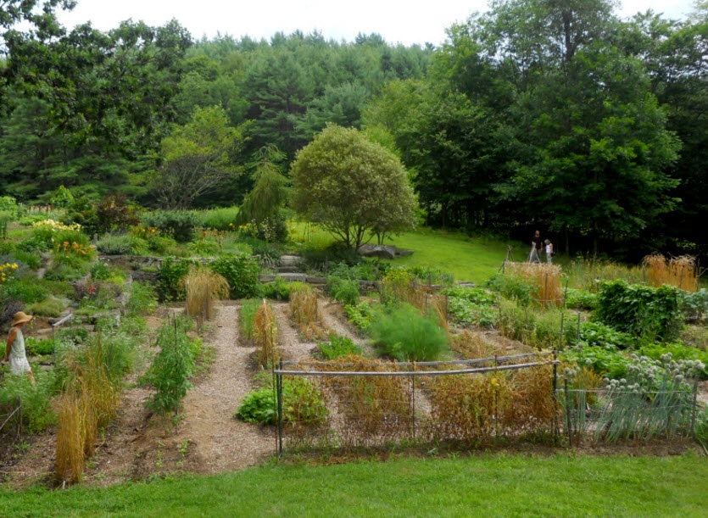
Seed Sharing at the Upper Valley (VT) library
- Ideas for building a seed library at
https://uvlocalvores.wordpress.com/2014/01/05/hartland-seed-library/
From the website of seed banker Sylvia Davatz of Hartland, VT, whose garden is pictured above.
- The 2017 (and final) Solstice Seed Catalog at
https://uvlocalvores.files.wordpress.com/2017/01/solsticeseeds_2017.pdf
Sylvia’s current catalogue. Based, not on the most popular seeds, but on the seeds she believes are most in need of saving.
- A model for a seedsaving group at
http://uppervalleyseedsavers.pbworks.com/w/page/50320963/FrontPage
Wiki workspace templates and procedures for setting up individual projects. A great “how to” resource that makes it easy to get started.

