SYLVIA DAVATZ: A LOCAL HERO
A link to Sylvia’s current (and final) open-pollinated seed catalog. Next year she’ll become a supplier to Seed Savers Exchange.
https://uvlocalvores.wordpress.com/2015/01/12/sylvia-davatz-solstice-seed-catalog/

UPPER VALLEY LOCAVORES SEED BANK HARTLAND, VERMONT
Explore the website, and learn about the Upper Valley Locavores and their exciting activities to maintain year-round local sources of good food. For example, learn about year-round local food sourced using frozen local produce at https://uvlocalvores.wordpress.com/2011/12/08/neighboring-food-co-ops-frozen-veggies/

Farmer Up! – An appearance in Hartland by Janisse Ray
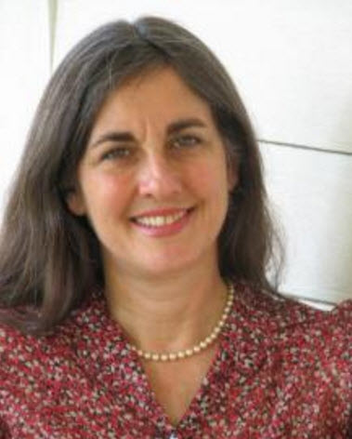
“Rev up your awesome. Look around, so many people have their shoulders into the load. You. Pick a place to push. Pick up a tool–a hoe or a shovel. Start turning the compost bin, to make the soil in which the seed will grow. You will begin at the center, the center of many concentric circles that expand further and further out from you. You will become a local hero and a local rock star, and from there your influence will wash outward, even across the globe, where so many people are rising up like germinating embryos to claim food sovereignty, to rescue local seeds, and to guard human civilization’s cornucopia. Come home. Have the courage to live the life you dream: There is nothing greater than this. Begin now. Are you going to farmer up or just lie there and bleed?” – Janisse Ray, The Seed Underground: A Growing Revolution to Save Food

