Nutsedge: The Edible Garden Foe
2/23/2011
By Lindsey Siegel
Nutsedge has gotten a bad rap, but for good reason. This pesky weed has been known to infest gardens, spreading thousands of nutlets underground and reproducing at an alarming rate (see our readers’ nutsedge woes). While this rather invasive plant has caused many a groan from gardeners, it has one redeeming quality: nutsedge is edible.
Yellow nutsedge (Cyperus esculentus), sometimes called Earth almond or Chufa, has tuberous roots that can be eaten raw or cooked. Their sweet, nutty flavor makes them ideal for a multitude of recipes, from soups to sweets. According to Cornucopia II: A Sourcebook of Edible Plants, yellow nutsedge was used to add sweetness to ancient Egyptian barley juice, and in Spain, the tubers are added to horchata de chufa (see photo), a beverage “prepared by mixing the ground tubers with water, cinnamon, sugar, vanilla and ice.”
Purple nutsedge (Cyperus rotundus) also has edible roots. Freshly-dug purple nutsedge has a strong menthol flavor that Cornucopia II compares to Vicks VapoRub, so, while the raw tubers can be eaten immediately, they’re best after drying. Like the yellow variety, purple nutsedge can be eaten boiled or roasted.
William Woys Weaver even suggests growing your own nutsedge for food in his book, “Heirloom Vegetable Gardening.” Praising the tubers’ similarities to other nuts, he says, “In texture, [nutsedge] is somewhat mealy like a chestnut, yet with a distinct almondlike flavor. It was used by country people as an almond substitute in cookies and confectionery, and was even pounded with sugar to make a type of faux marzipan once quite popular among the Pennsylvania Germans.”
If you’ve got a nutsedge invasion on your hands, it may be hard to see the situation as anything other than aggravating. The April/May 2011 issue of MOTHER EARTH NEWS will contain some great tips on how to kick the weeds for good. Until then, don’t hesitate to turn a somber situation into a delicious one.

From WIKIPEDIA: Cyperus esculentus (also called chufa sedge, nut grass, yellow nutsedge, tiger nut sedge, or earth almond) is a crop of the sedge family widespread across much of the world. It is found in most of the Western Hemisphere, as well as Southern Europe, Africa, Madagascar, the Middle East, and the Indian subcontinent. Historically it has become naturalized in many other regions, including Ukraine, China, Hawaii, Indochina, New Guinea, Java, New South Wales, and various oceanic islands.^{[2][3][4][5]}
Cyperus esculentus can be found wild, as a weed, or as a crop. Evidence exists for its cultivation in Egypt since the sixth millennium BC, and for several centuries in Southern Europe. In Spain, C. esculentus is cultivated for its edible tubers, called earth almonds or tiger nuts, for the preparation of horchata de chufa, a sweet, milk-like beverage. However, in most other countries, C. esculentus is considered a weed.^{[6]}
It has been suggested that the extinct hominin Paranthropus boisei, the "Nutcracker Man," subsisted on tiger nuts.^{[7]} Prehistoric tools with traces of C. esculentus tuber starch granules have been recovered from the early Archaic period in North America, from about 9,000 years ago, at the Sandy Hill excavation site at the Mashantucket Pequot Reservation in Mashantucket, Connecticut. The tubers are believed to have been a source of food for those Paleo-Indians.^{[8]}
Zohary and Hopf estimate that C. esculentus "ranks among the oldest cultivated plants in Ancient Egypt." Although noting that "Chufa was no doubt an important food element in ancient Egypt during dynastic times, its cultivation in ancient times seems to have remained (totally or almost totally) an Egyptian specialty."^{[9]} Its dry tubers have been found in tombs from predynastic times about 6000 years ago. In those times, C. esculentus tubers were consumed either boiled in beer, roasted, or as sweets made of ground tubers with honey.^{[10]} The tubers were also used medicinally, taken orally, as an ointment, or as an enema, and used in fumigants to sweeten the smell of homes or clothing.^{[11]} There are almost no contemporary records of this plant in other parts of the old World.
Besides Egypt, at present C. esculentus is cultivated mainly in Spain, where it is extended for common commercial purposes in mild climate areas. The plant was introduced by the Arabs, first in the Valencia region. They are found extensively too in California and were grown by the Paiute in Owens Valley. C. esculentus is also cultivated in countries such as Guatemala, Mexico, Chile, Brasil, the United States, Lebanon, Syria, Jordan, Saudi Arabia, Oman, Iran, Iraq, Pakistan, India, Yemen, Morocco, Ivory Coast, Sudan, South Sudan, Gambia, Guinea Bissau, Ghana, Niger, Nigeria, Burkina Faso, Togo, Benin, Northern Cameroon, and Mali, where they are used primarily as animal feed or uncooked as a side dish, but in Hispanic countries they are used mainly to make horchata, a sweet, milk-like beverage. In Northern Nigeria, it is called aya and it is usually eaten fresh. It is sometimes dried and later rehydrated and eaten. Also a snack is made by toasting the nuts and sugar coating it is popular among the Hausa children of Northern Nigeria. Also, a drink known as kunun aya is made by processing the nuts with dates and later sieved and served chilled.

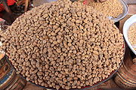
Use as food[edit]
Dried tubers sold at the market of Banfora, Burkina Faso
The tubers are edible, with a slightly sweet, nutty flavour, compared to the more bitter-tasting tuber of the related Cyperus rotundus (purple nutsedge). They are quite hard and are generally soaked in water before they can be eaten, thus making them much softer and giving them a better texture. They are a popular snack in West Africa, where they are known as ncɔkɔn in the Bamnara (Mali) or Dyula, Aya, Hausa Groundnut, Ofio, Keegun, Isip Osong, Aya or Iki Awausa in Nigeria.
They have various uses; in particular, they are used in Spain to make horchata. “Horchata” is a nonalcoholic beverage of milky appearance derived from the tubers of the tiger nut plant mixed with sugar and water. It has a great economic impact in the Valencian region of Spain.
Flour of roasted tiger nut is sometimes added to biscuits and other bakery products as well as in making oil, soap, and starch extracts. It is also used for the production of nougat, jam, beer, and as a flavoring agent in ice cream and in the preparation of kunnu (a local beverage in Nigeria).^{[25]} Kunnu is a nonalcoholic beverage prepared mainly from cereals (such as millet or sorghum) by heating and mixing with spices (dandelion, alligator pepper, ginger, licorice) and sugar. To make up for the poor nutritional value of kunnu prepared from cereals, tiger nut was found to be a good substitute for cereal grains. Tiger nut oil can be used naturally with salads or for deep frying. It is considered to be a high quality oil. Tiger nut “milk” has been tried as an alternative source of milk in fermented products, such as yogurt production, and other fermented products common in some African countries and can thus be useful replacing milk in the diet of people intolerant to lactose to a certain extent.^{[6]}
Tiger nuts should be eaten in only moderate amounts at any one time. Ingestion of 300 g of the fibrous dehydrated nuts, chewed without being rehydrated,^{[15]} has been known to cause fecal impaction.

Nutritional value[edit]
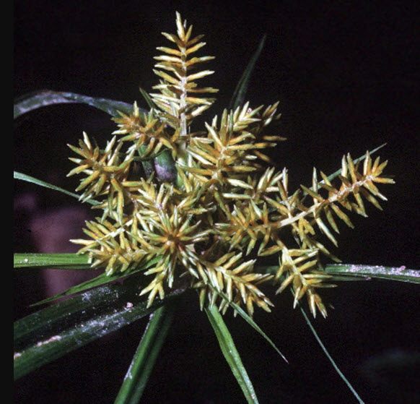
Despite its name, tiger nutsedge is a tuber. However, its chemical composition shares characteristics with tubers and with nuts. It has been reported to be a "health" food, since its consumption can help prevent heart disease and thrombosis and is said to activate blood circulation and reduce the risk of colon cancer.^{[26][qualify evidence]} This tuber is rich in energy content (starch, fat, sugar, and protein), minerals (mainly phosphorus and potassium), and vitamins E and C. Tiger nut tubers contain almost twice the quantity of starch as potato or sweet potato tubers. The oil of the tuber was found to contain 18% saturated (palmitic acid and stearic acid) and 82% unsaturated (oleic acid and linoleic acid) fatty acids.^{[27]}The moderately high content of phytosterols further enriches the quality and value of tiger nut oil as a food source.

Use in medicine and cosmetic industry[edit]
As a source of oils, the tubers were used in pharmacy under the Latin name bulbuli thrasi beginning no later than the end of 18th century.^{[30]} In ayurvedic medicine tiger nuts are used in the treatment of flatulence, diarrhoea, dysentery, debility and indigestion.^{[22]} Tiger nut oil can be used in the cosmetic industry. As it is antidioxide (because of its high content in vitamin E) it helps slow down the ageing of the body cells. It favours the elasticity of the skin and reduces skin wrinkles.^{[21]}

